1. Top Header: Please find below image for top of header of website. Is up to you how you will design and present this. We will keep Indian number as of now US number will be provide shortly to you and colour will be same as below page have i guess it’s navy blue.
Correction is below
2. Logo Alignment: Logo should be present like as below and should be perfectly fit into this. Please find reference. Please also make sure colour combination not be unmatched I just take an image from ChatGPT for your reference

Correction is below
Can you please change here to “Talk to Us” Instead “Books a Free Discovery call”?
3. Remove Privacy Page from Resource tab
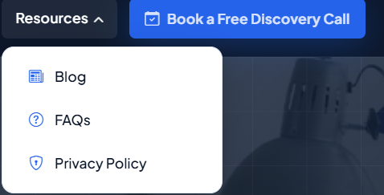
4. We need to remove purple colour mark except professional image try to highlight image more that should be visible. Presentation Idea go with this link ( https://annantam.com/ ). Also, can you please have changed “Book Free Discovery Call” to “Start your 20-Hour Free Trail”
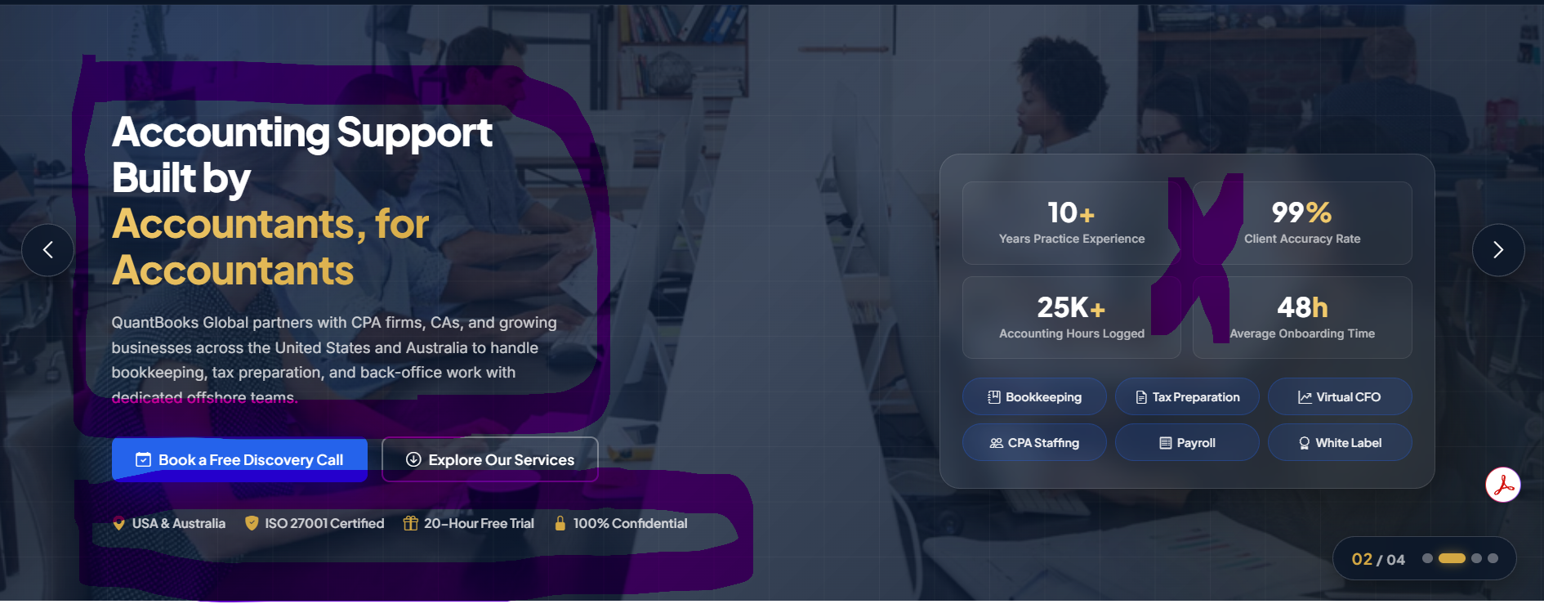
Correction: Need two carousals first one is for SMBs and second one is for CPA and Accounting firms with different pics
Content for first carousal with corporate background image with visibility: Outsourced Accounting and Tax Solutions for SMBs
Content for second carousal with corporate background image with visibility: Outsourced Accounting Services for CPAs and Accounting firms. Examples are below you can make better version and presentation.
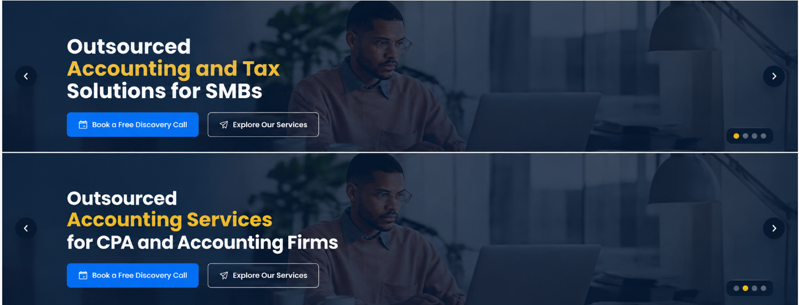
5. The Software We Work With section will appear after the testimonials. Since we serve clients across two countries — the USA and Australia — the software platforms we support vary by country and by service. I have shared a Word file containing the complete list of software categorized by Accounting, Tax, Sales Tax, and Payroll. Currently, some software logos on our website appear inconsistent in size, spacing, and miss alignment. I would like you to source the official, high-quality logos where required and standardize their dimensions, proportions, spacing, and alignment so that all logos have a clean, balanced, and professional appearance. For the presentation, please find below image for your reference

Header Content: Software Stack Behind Our Outsourced Solutions
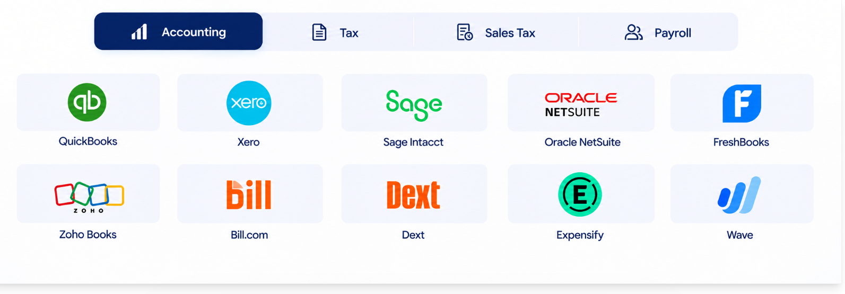
6. About us the image is good but can you replace this current image which looks more professional and corporate pic? Can you add counting number function here? I have change about us content little bit and make it fit and more visible
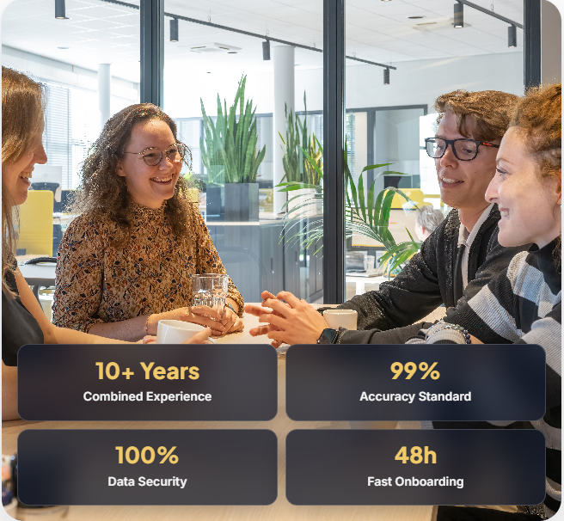
Correction is below. This is example you can choose with best corporate pic accordingly.
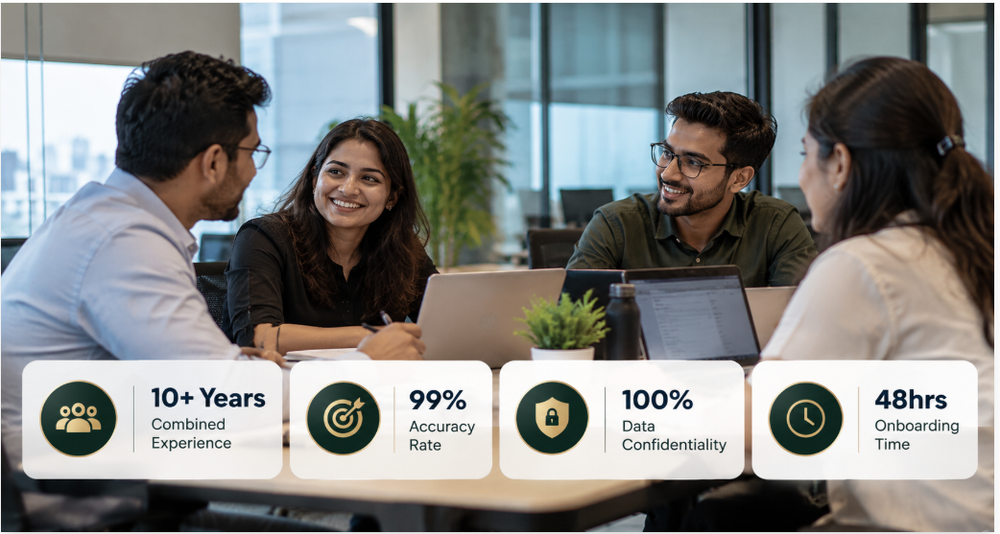

Content for About us:
Founded by Accountants, Built for Practice Growth ❌
Your Trusted Outsourcing Partner ✔️
QuantBooks Global is a result-driven blended shore outsourced accounting and tax services provider to small and mid-sized businesses, CPAs, CAs, EAs, and accounting firms across the USA and Australia. We provide end-to-end accounting and tax outsourcing solutions, helping our clients to extend their capacity, improve efficiency, and focus on their core competencies.
We don’t view outsourcing as simply completing tasks or reducing costs. Our purpose is to give you the capacity you need today while creating a room for growth tomorrow. Our approach is built around four core commitments: accuracy, accountability, security, and excellence.
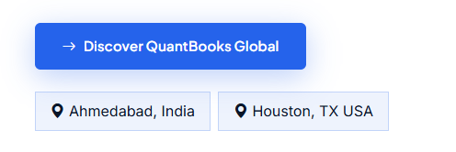
Can you please add “Explore more” instead Discover QuantBooks Global? And can you please remove location from here?
7. Services: We need to changed content in Main header and Pera header also we have to remove one service from here which is “Back – Office / Virtual Assistant”. Also need to change Pera Content please find below correction
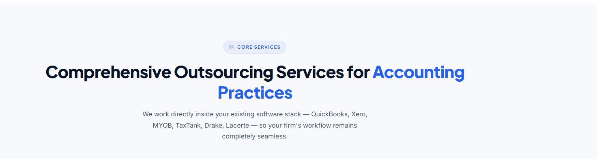
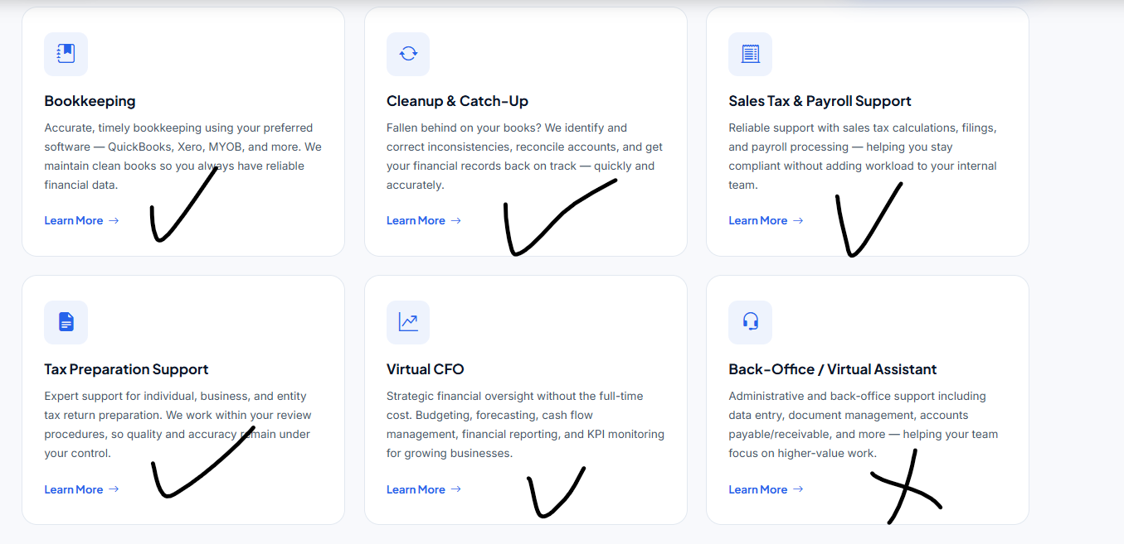
Correction:
Main Header Content: Customized Outsourcing Services for Business
Pera Header Content: Outsourced bookkeeping and accounting services under one monthly engagement, from daily transactions to the return that gets prepared.
Now for each service there is little bit content about then “learn more” button I have changed content for the same please find below for each service
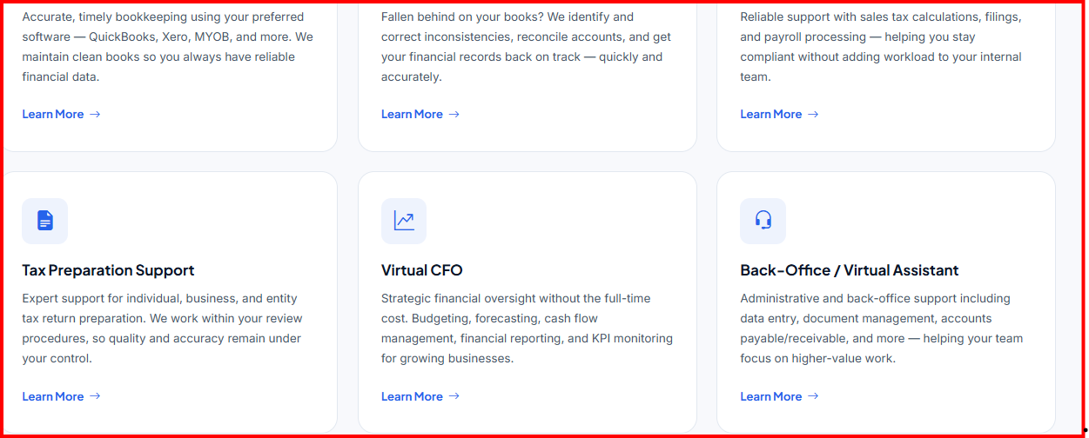
Bookkeeping: Every transaction coded, every account reconciled and we maintain clean books so you always have reliable financial data.
Cleanup & Catch-Up: Years of backlog? We identify and correct inconsistencies, reconcile accounts, and get your financial records back on track.
Sales Tax and Payroll Support: From pay runs to sales tax filings, we help you stay compliant with reliable outsourcing support that fits seamlessly into your business.
Tax Preparation Support: Expert support in preparing individual and business tax returns, working closely with your CPA throughout tax season.
.
Virtual CFO: Need CFO-level support without the cost of a full-time hire? We help you manage budgeting, forecasting, keep an eye on cash flow and KPI monitoring so you always have a clear view of your finances.
8. Now jumped to CPA and Accounting firm section. Need to change this content below.

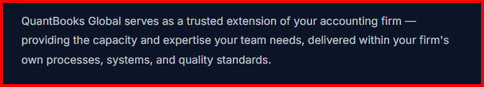
Correction Content: Outsourced Accounting Solutions for CPAs and Accounting Firms
Correction Pera Content: We’re not just another outsourced accounting provider. We’re your silent partner, working in the background so your clients get the best service from you while we handle the complex & time-consuming tasks and work as an extension of your onshore team.
We have to remove some of services listed in this section please find them below with cross mark and remove content as well.
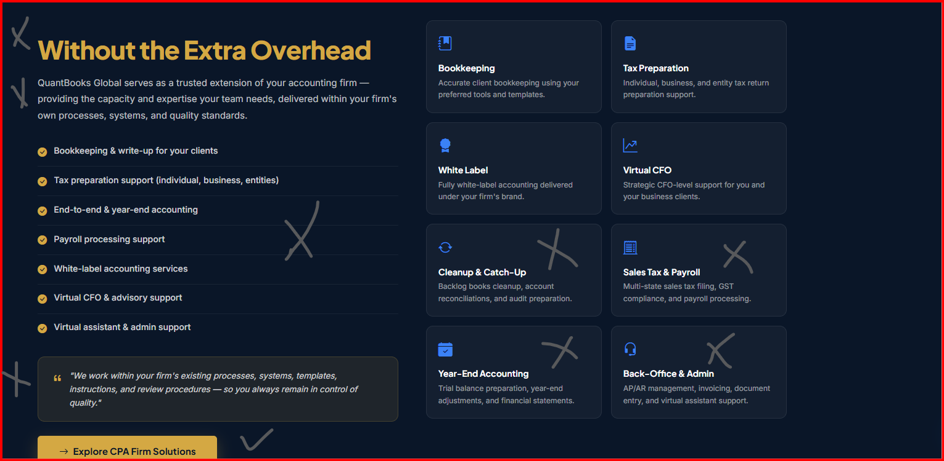

9. Our Commitment section: Need to change Main header content and I slightly changed Pera content. Rest Six points are good to go no changes.
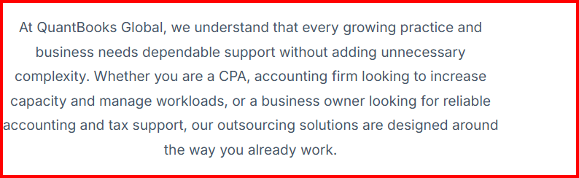
Main Correction Content: Why Choose Us
Pera Content: At QuantBooks, we understand that every growing CPA practice and business needs dependable support without adding unnecessary complexity. Our outsourcing solutions are designed around the way you already work helping streamline operations and focus on what matters most.
10. Our Core Commitment Section: Can you please change “Our Core Commitment” instead “Our Core Values”. Rest is good. Thanks for adding this.
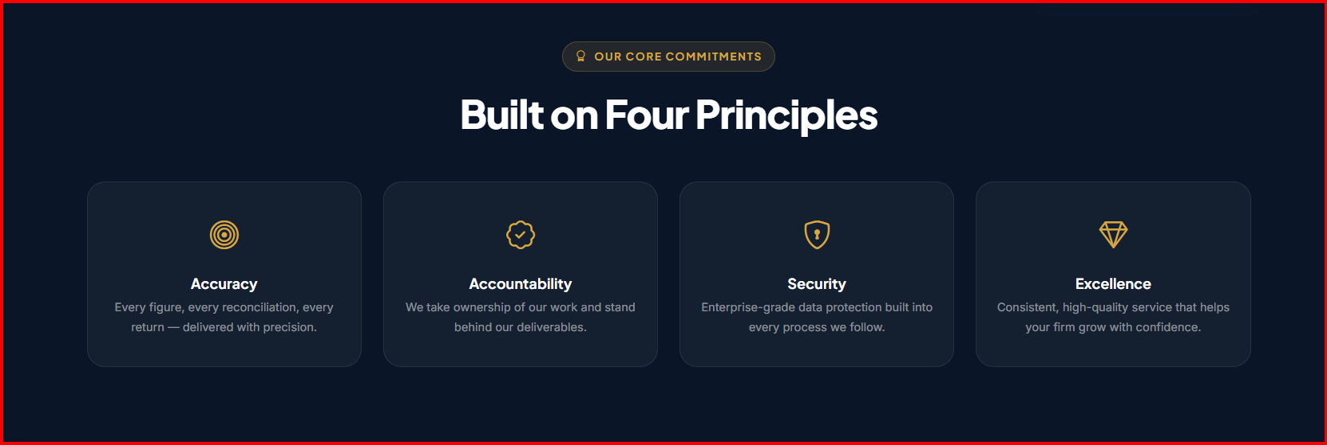
11. Top Reason: Will show case separately by country. And don’t mention country name here just counting number and ensure that works well. And remove circle content.

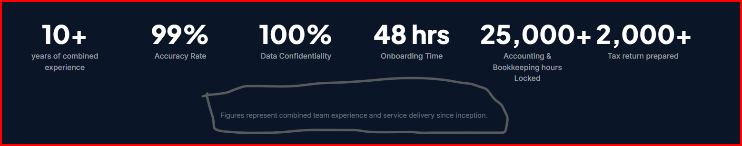
12. Our Journey: Need to changed main content and little bit of starting point of every year and rest are not change.
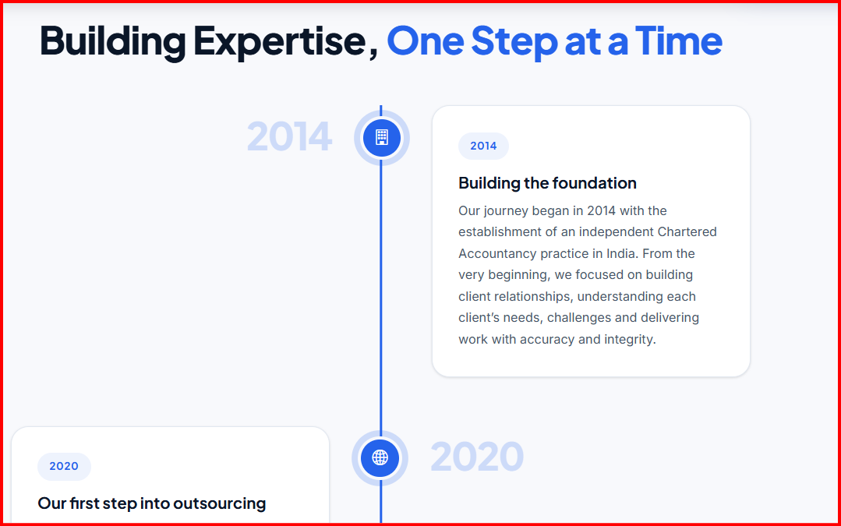
Building Expertise, One Step at a Time ❌
Pathway to Excellence ✔️
Building the foundation ❌
Humble Beginnings ✔️
Our first step into outsourcing ❌
Our First Step Into Outsourcing ✔️
13. Remove Founder Profile from Home Page
14. Vision and Mission: That should be after about us on home page and remove back office content from our mission and add “Virtual CFO” instead no changes here.
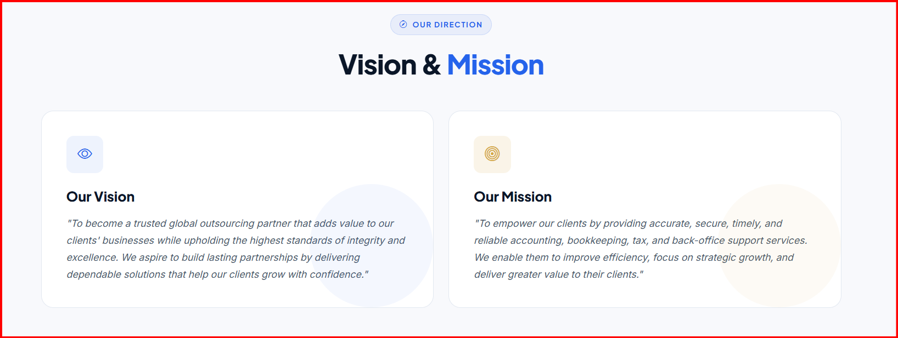

15. Data Security: I guess entire data security page is mentioned on home page. Please find image how we want to showcase image are below. If you think that we need to show some of card on home page you can do this. Also, when you design page of data security can we have rotated card like when click on Biometric Access then card will be rotate and content will be show?
Idea: Add How we handle your data button or you can put other what you like 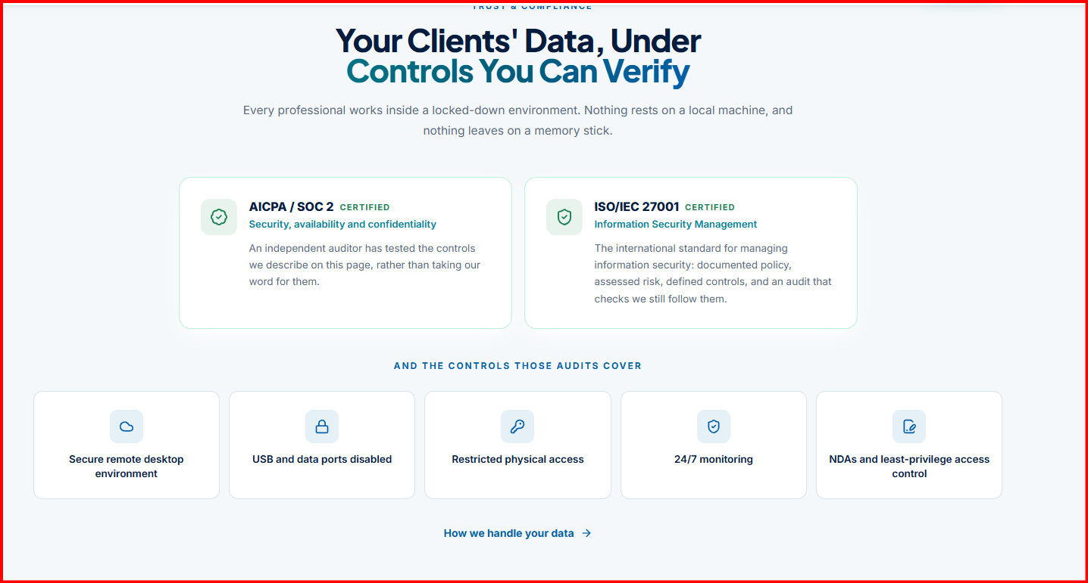
Correction Content
Your Financial Data Deserves Serious Protection❌
Your Data Protected at Every Step ✔️
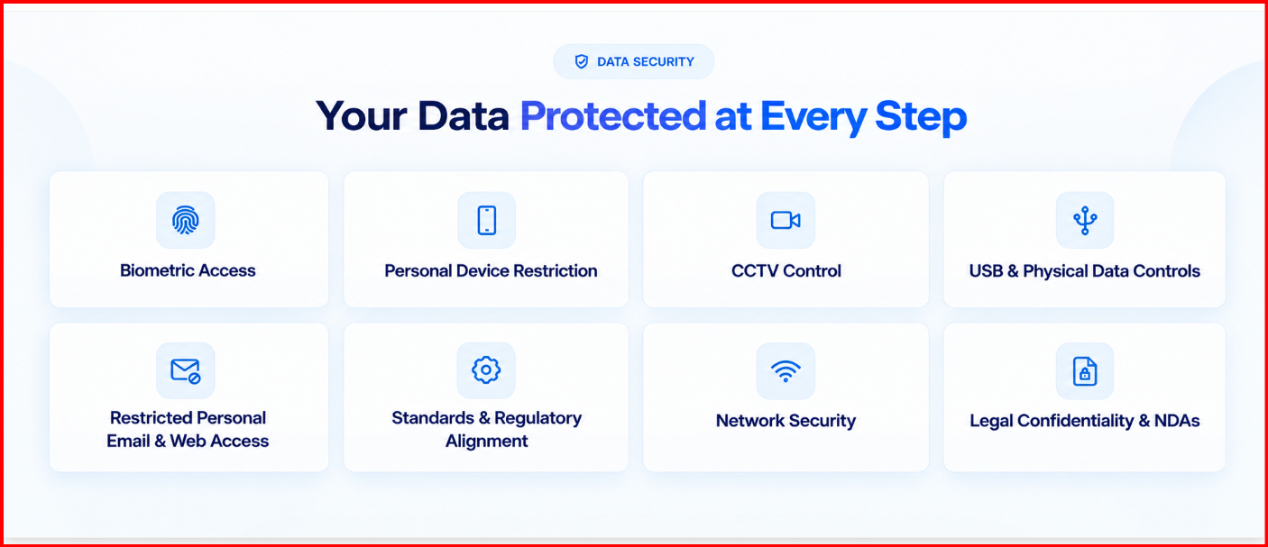
16. Certification & Standard: Need to change entire page for the same. Find how we can design and showcase for the same
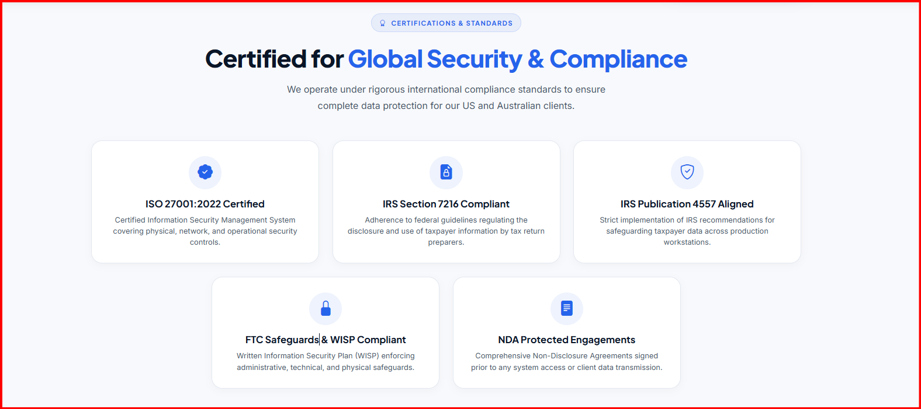
Only want Main Header content with moving function on this: Certified on the platforms you already use
Certification


Idea:
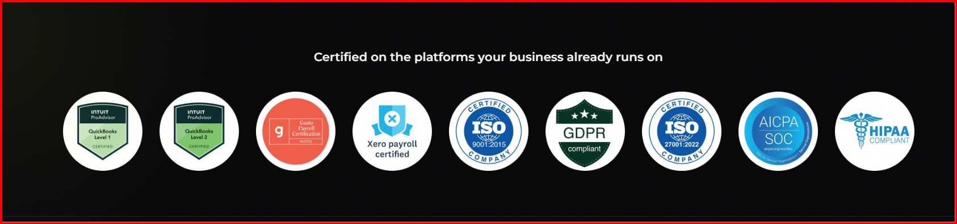
17. How it works: I have changed little bit Pera header content for better understanding. I realised that process from step 1 to end is complicated so I reframe entire page for your reference please find below. If you feel grammatical error also adjust and reframe this.
Correction Page
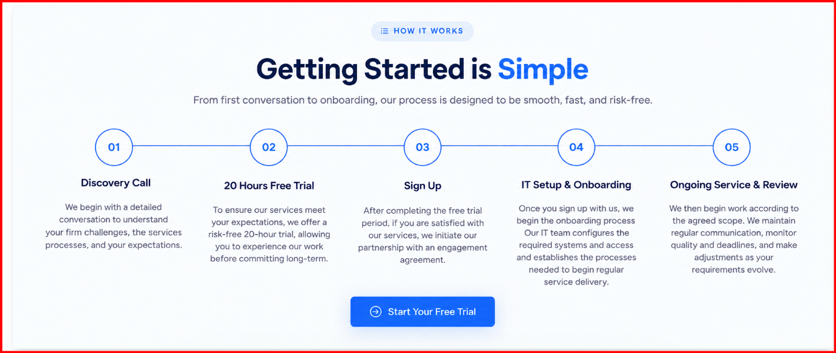
18. Industries We Serve: Perfect! Good job on this no need to change. We can do this like on home page just mentioned industries name with logo and when someone jump on industries page then card will be rotate and content will be show
19. Client Testimonials: Need correction on main content. Also, we need sperate testimonial country wise with not mentioned country like “USA Testimonials”. Remove one testimonial from AUS country keep only three which I provided.
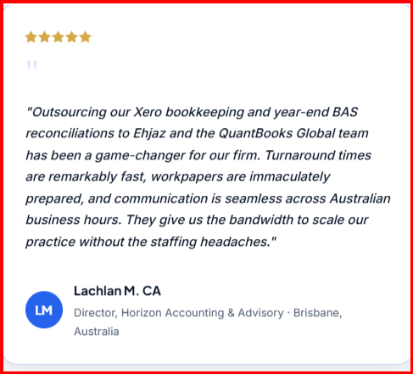
What Our Clients Say About QuantBooks Global❌ What Our Clients Say✔️
20. FAQ’s: Remove from home page
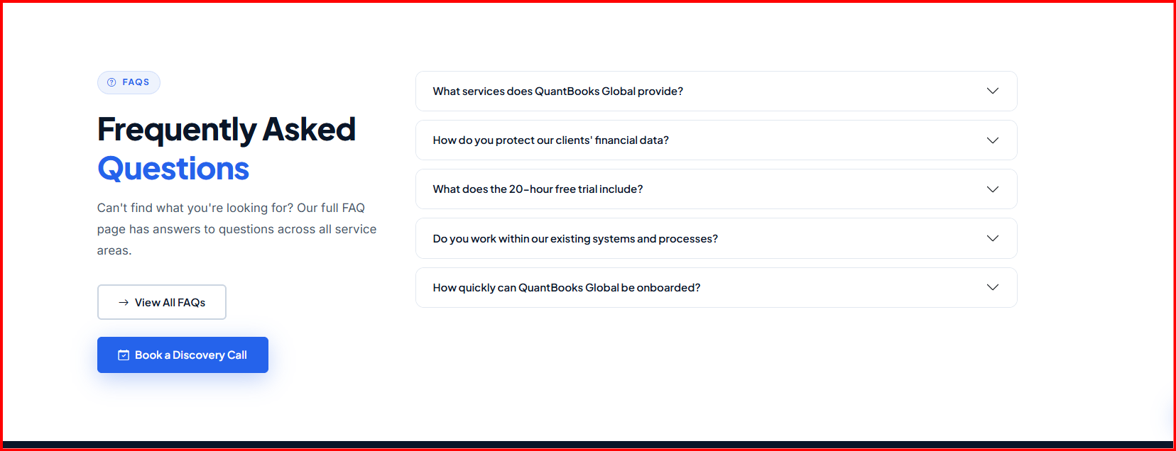
21. Schedule a Practice Consultation: Need to redesign this. Please find below

Idea: https://www.adasglobuspro.com/
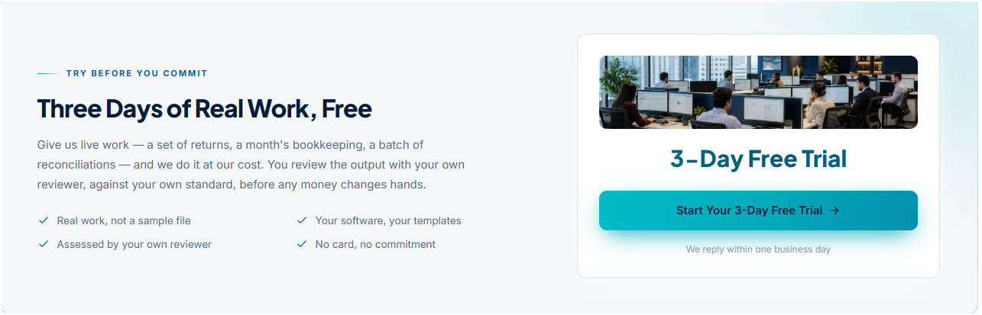
Correction Page: You can design changed content accordingly which looks organic.
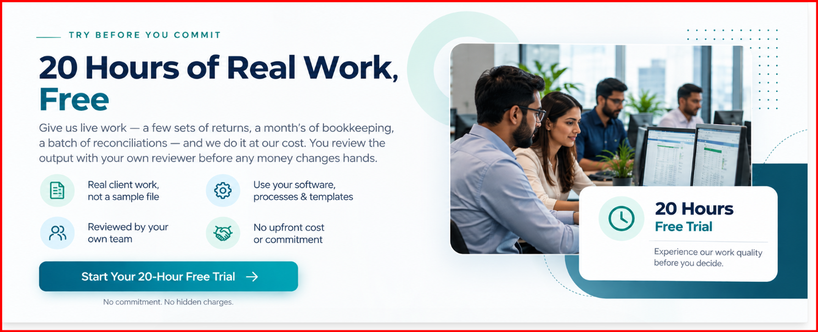
22. Contact us Page: Need little bit changes remove service which is crossed marked in below image. Remove India Office and USA address from here and add only “Operations” Ahmedabad, India. As of now keep Indian number US number will provide you shortly.
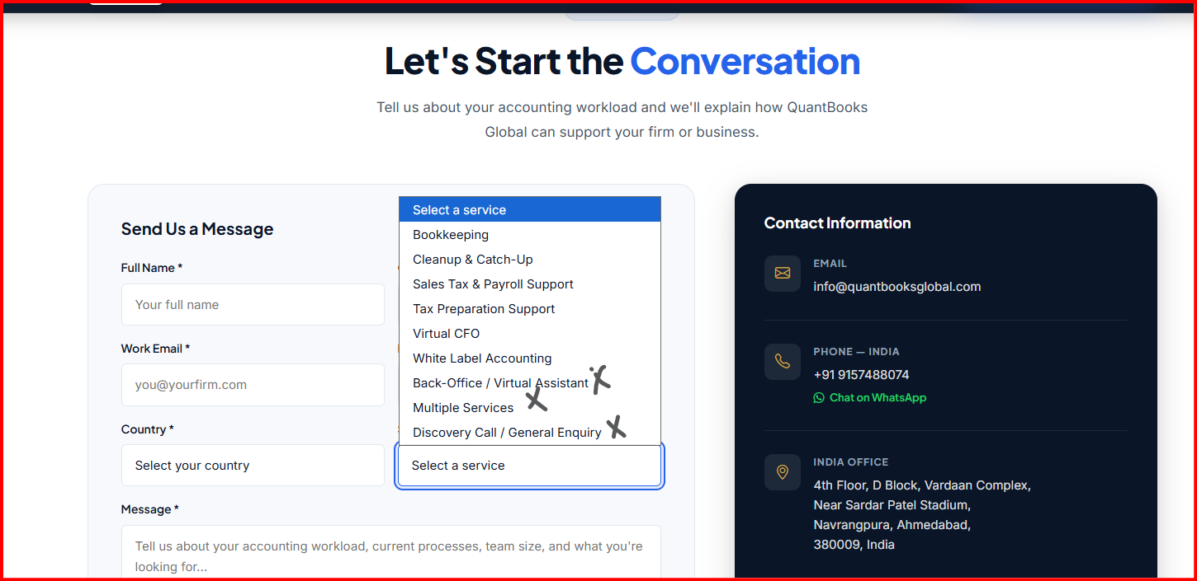
Idea:
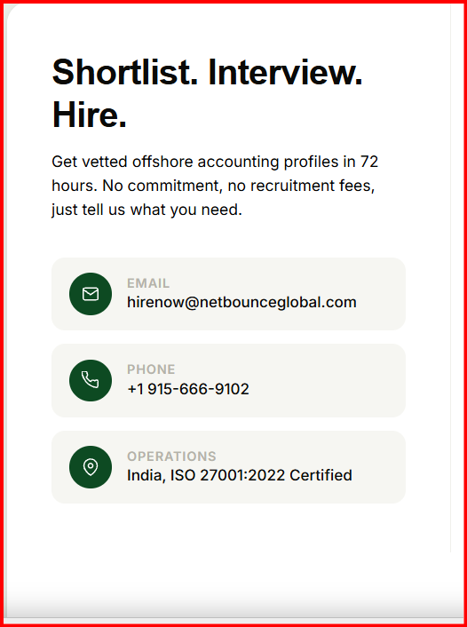

23. Footer: Some changes will be needed. Correction page idea you can adjust and design it better way. Clock idea have shared below those are for US time zone for Australia you can adjust from your side. Mountain time zone we want to remove.
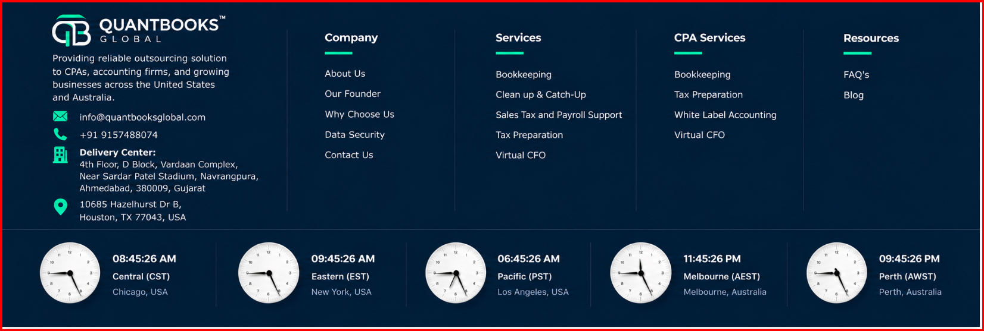
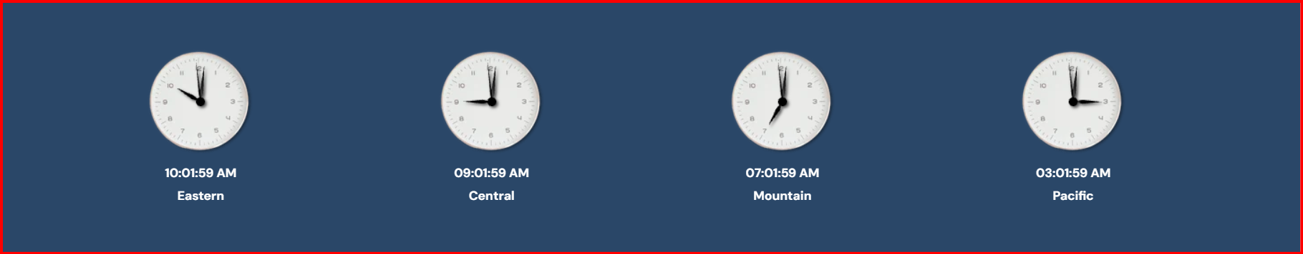
Social Media icons are missing on this footer page please add those accordingly. We are on LinkedIn, Instagram and Facebook. Also, Delivery Center will be India address and US office address will be same. Like
Delivery Address:
India Address
US Office:
US Address
24. B2B Market Place Logo: As we discussed we also want B2B market place logo like Clutch, Design Rush and Good Firms. I have attached logo for your reference please adjust accordingly on home page.



